Week 6 Internship Documentation
Infosys Springboard Internship | Data Visualization Domain
Topic Focus: Data Modeling, Star Schema, and DAX Measures (Theory + Basic Practical)
Prepared by: Prabhakar Kumar Shahi
Project: Optimizing IT Support Team Performance Using Analytics


1. Introduction
During Week 6 of the internship, the focus moved to one of the most important topics in Power BI: data modeling and DAX (Data Analysis Expressions). The session covered both theory and basic practical understanding using a dummy dataset, with emphasis on why modeling is necessary, how multiple tables are related, and how DAX measures are created to support meaningful business analysis.
This week is highly important because a good dashboard is not built only on visuals. It depends on a well-structured data model and strong DAX logic. Even though the project dataset currently exists in a single flat table, professional Power BI reporting usually requires multiple related tables for better performance, scalability, readability, and advanced calculations.

2. What is Data Modeling in Power BI?
Data modeling is the process of organizing data into logical tables and defining relationships between them so that Power BI can analyze the data efficiently. Instead of keeping everything in one large flat table, the data is often split into fact and dimension tables. This approach improves performance, reduces redundancy, simplifies calculations, and makes the model easier to understand.
- Data modeling defines how tables are connected
- It controls how filters flow between tables
- It supports accurate aggregation and DAX calculations
- It enables star schema and dimensional analysis
- It improves dashboard performance and maintainability

3. Why Modeling is Important
Reason | Explanation
Performance | Smaller dimension tables and optimized relationships improve report speed
Scalability | Easy to extend the model when new data or tables are added
Readability | Cleaner structure makes the report easier to maintain
Reusability | Measures become easier to reuse across visuals
Accuracy | Proper relationships reduce the chance of incorrect aggregations
Time Intelligence | A separate date table improves date-based analysis

4. Basic Modeling Concepts
- Fact Table – Main transactional table containing measurable events
- Dimension Table – Descriptive tables used for filtering and slicing
- Primary Key – Unique identifier in a dimension table
- Foreign Key – Key in fact table that connects to a dimension table
- Relationship – Logical link between two tables
- Cardinality – One-to-many, many-to-one, or many-to-many relationship type
- Cross Filter Direction – Controls how filters flow between related tables
- Star Schema – Best practice model with one central fact table and multiple dimensions
- Snowflake Schema – More normalized but often more complex than star schema

5. Star Schema for the Support Ticket Dataset
Since the current dataset is a single flat table, it can be transformed into a star schema for professional modeling. In a star schema, the central fact table stores ticket-level events and measures, while surrounding dimension tables store descriptive attributes.
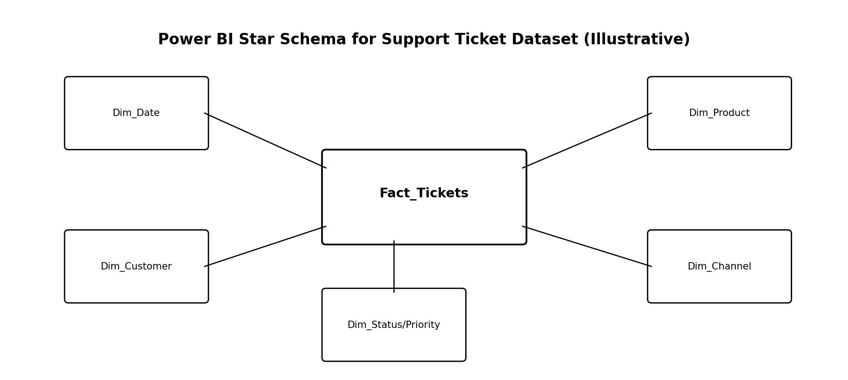
Figure 1: Illustrative star schema design for the support ticket project

5.1 Central Fact Table
Fact Table | Recommended Columns
Fact_Tickets | ticket_id, product_key, customer_key, date_key, channel_key, status_key, priority_key, region_key, customer_satisfaction_score, first_response_time_hours, resolution_time_hours, previous_tickets, issue_complexity_score, escalated, sla_breached

5.2 Possible Dimension Tables from Your Single Dataset
Dimension Table | Suggested Columns | Purpose
Dim_Date | ticket_created_date, ticket_resolved_date, Year, Month, Quarter, Day | Time intelligence and trend analysis
Dim_Customer | customer_name, customer_email, customer_age, customer_gender, subscription_type, customer_tenure_months, customer_segment | Customer profiling and segmentation
Dim_Product | product, category, operating_system, browser, payment_method | Product and technical environment analysis
Dim_Channel | channel, preferred_contact_time, language, region | Support channel and regional analysis
Dim_StatusPriority | status, priority, escalated, sla_breached | Operational ticket state and urgency analysis

5.3 Additional Optional Tables (Advanced)
- Dim_Region – If region analysis becomes large and needs hierarchy
- Dim_Subscription – If subscription_type needs separate business rules
- Dim_IssueCategory – If category and issue complexity need deeper analysis
- Calendar Table – Recommended separate date table instead of using dates directly from fact

6. Advantages and Disadvantages of Modeling
Advantages | Disadvantages / Challenges
Better performance in large datasets | Requires more setup and planning
Cleaner and more professional report design | Can be confusing for beginners initially
Easier DAX measure creation | Incorrect relationships can produce wrong results
Improved filter behavior | Too many tables can complicate navigation
Supports reusable logic and star schema | Needs careful naming and documentation
Better support for time intelligence | Dummy or small datasets may seem simpler in one table

7. Introduction to DAX (Data Analysis Expressions)
DAX stands for Data Analysis Expressions. It is the formula language used in Power BI, Power Pivot, and Analysis Services for creating measures, calculated columns, and calculated tables. DAX is essential because it allows analysts to perform dynamic calculations that change based on filters, slicers, and visual context.
- Used for Measures
- Used for Calculated Columns
- Used for Calculated Tables
- Supports aggregations, logical conditions, filtering, ranking, time intelligence, and more

8. Types of DAX Objects
DAX Object | Meaning | When to Use
Measure | Dynamic calculation evaluated based on filter context | Best for KPIs and visuals
Calculated Column | Computed value stored row by row in a table | Use for row-level classification or keys
Calculated Table | New table created using DAX | Use for advanced modeling or helper tables

9. Measures vs Calculated Columns
Aspect | Measure | Calculated Column
Evaluation | Calculated at query time | Calculated at data refresh time
Storage | Not stored row-by-row | Stored in the model
Best For | KPIs, aggregations, dynamic logic | Row-level labels, categories, flags
Performance | Usually more efficient for analytics | Can increase model size
Context | Uses filter context | Uses row context

10. DAX Context – Core Theory
Understanding context is the heart of DAX. Most DAX errors happen because the analyst does not understand how context works.
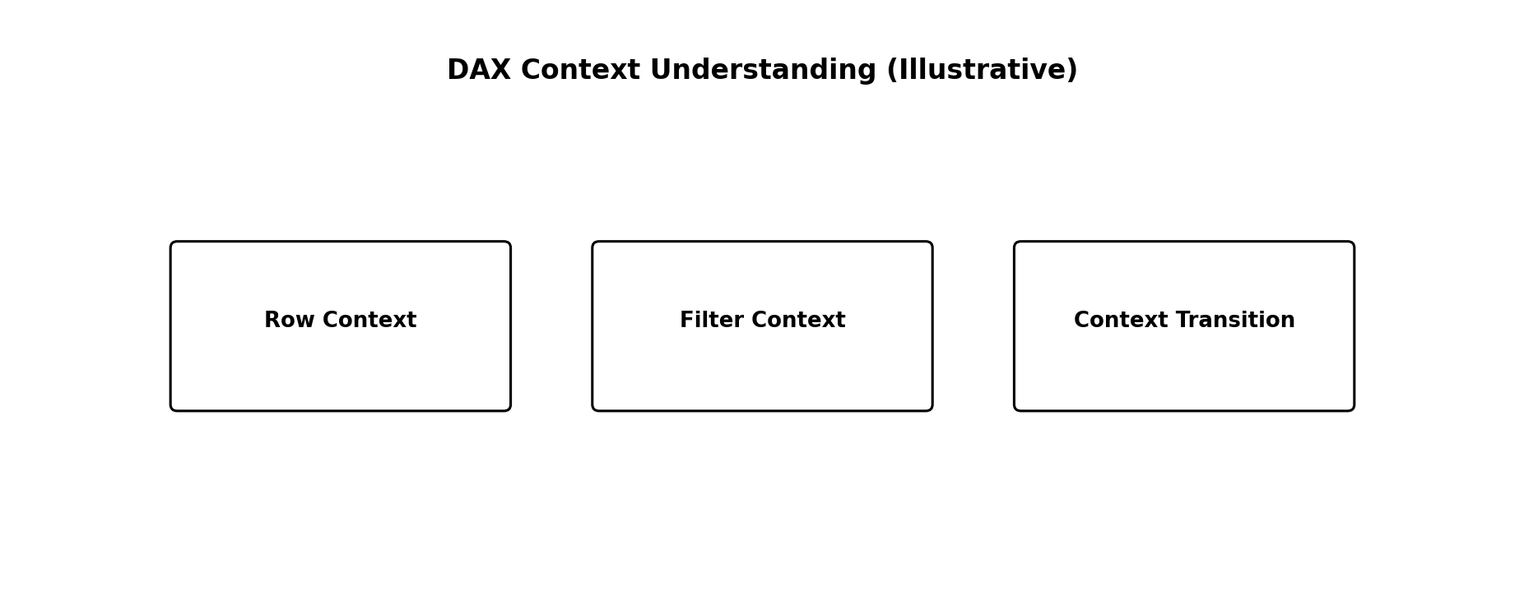
Figure 2: Core DAX context concepts used in Power BI
- Row Context – Exists when a formula is evaluated row by row, usually in calculated columns or iterators
- Filter Context – The set of filters applied by visuals, slicers, rows, columns, and page/report filters
- Context Transition – When row context is converted into filter context, usually by CALCULATE

11. Base Measures, Derived Measures, Composite Measures, and Final KPIs
A professional DAX workflow often follows a layered structure. First, simple base measures are created. Then derived or intermediate measures are built from them. After that, composite measures combine multiple measures or business rules. Finally, KPI measures are created for reporting.
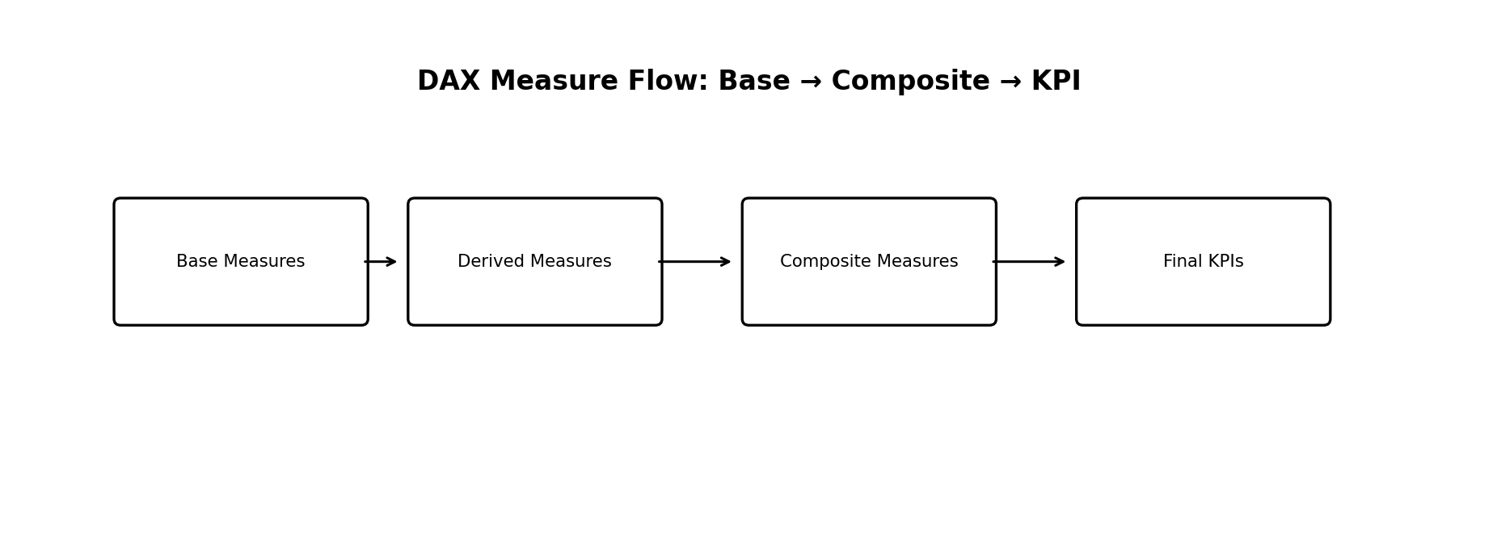
Figure 3: Professional DAX measure development flow

11.1 Base Measures
Base Measure | Example DAX | Purpose
Total Tickets | Total Tickets = COUNT('Fact_Tickets'[ticket_id]) | Counts all tickets
Avg First Response | Avg First Response = AVERAGE('Fact_Tickets'[first_response_time_hours]) | Average response time
Avg Resolution Time | Avg Resolution Time = AVERAGE('Fact_Tickets'[resolution_time_hours]) | Average resolution time
Avg Satisfaction | Avg Satisfaction = AVERAGE('Fact_Tickets'[customer_satisfaction_score]) | Average service rating

11.2 Derived / Intermediate Measures
Derived Measure | Example DAX | Purpose
Closed Tickets | Closed Tickets = CALCULATE([Total Tickets], 'Dim_StatusPriority'[status] = "Closed") | Count only closed tickets
Open Tickets | Open Tickets = CALCULATE([Total Tickets], 'Dim_StatusPriority'[status] = "Open") | Count open tickets
Urgent Tickets | Urgent Tickets = CALCULATE([Total Tickets], 'Dim_StatusPriority'[priority] = "Urgent") | Count urgent workload

11.3 Composite Measures
Composite Measure | Example DAX | Purpose
Resolution Rate % | Resolution Rate % = DIVIDE([Closed Tickets], [Total Tickets], 0) | Closed tickets as a percentage
SLA Breach Rate % | SLA Breach Rate % = DIVIDE(CALCULATE([Total Tickets], 'Dim_StatusPriority'[sla_breached] = "Yes"), [Total Tickets], 0) | Percentage of SLA-breached tickets
Escalation Rate % | Escalation Rate % = DIVIDE(CALCULATE([Total Tickets], 'Dim_StatusPriority'[escalated] = "Yes"), [Total Tickets], 0) | Percentage of escalated tickets

11.4 Final KPI Measures
Final KPI measures are the measures actually shown in cards and executive visuals. These are often formatted and business-ready versions of base and composite measures.

12. Important DAX Function Categories
Function Category | Examples | Use
Aggregation | SUM, AVERAGE, MIN, MAX, COUNT, DISTINCTCOUNT | Basic summary calculations
Logical | IF, SWITCH, AND, OR | Conditional logic
Filter / Context | CALCULATE, FILTER, ALL, ALLEXCEPT, VALUES | Context modification
Iterator | SUMX, AVERAGEX, COUNTX | Row-wise calculations over a table
Math / Safe Division | DIVIDE, ROUND, ABS | Numeric operations
Text | CONCATENATE, FORMAT, LEFT, RIGHT | Formatting or label logic
Date / Time Intelligence | DATEADD, SAMEPERIODLASTYEAR, TOTALYTD | Date-based analysis
Relationship | RELATED, RELATEDTABLE, USERELATIONSHIP | Using relationships across tables

13. DAX Functions Most Useful for This Project
Function | Why Useful in This Dataset
COUNT / DISTINCTCOUNT | Count tickets and unique customers
AVERAGE | Average response, resolution, and satisfaction
CALCULATE | Apply business filters like Closed, Open, SLA Breached
DIVIDE | Safely calculate rates and percentages
IF / SWITCH | Create logical KPI categories or status buckets
FILTER | Create custom filtered calculations
SUMX / AVERAGEX | Advanced row-wise calculations when needed
ALL / ALLEXCEPT | Control filter behavior in comparisons
RELATED | Pull values across related tables if using star schema

14. Basic Practical on Dummy Dataset (Conceptual Example)
In the practical session, a dummy dataset can be used to understand how modeling works before applying it to the project dataset. For example, create a simple Sales-like or Ticket-like model with one fact table and two dimension tables. Then create relationships and build simple measures.
- Load a dummy dataset with ticket records
- Create a separate Date table and relate it to ticket created date
- Create a separate Status / Priority table if needed
- Create a simple Customer dimension
- Build one-to-many relationships from dimensions to fact table
- Create base measures such as Total Tickets and Average Resolution Time
- Create filtered measures such as Closed Tickets and SLA Breach Rate
- Use visuals to validate whether filters work correctly

15. Modeling Best Practices for Your Single-Table Dataset
- Start with a clean flat table, but split into dimensions if the project grows
- Always create a proper Date table for time intelligence
- Hide unnecessary technical columns from report view
- Use clear table and measure names
- Keep measures in a dedicated Measures table if possible
- Avoid many-to-many relationships unless absolutely required
- Prefer one-directional filtering unless business logic requires both directions
- Use star schema instead of over-normalized models for Power BI reporting

16. Common Modeling Mistakes to Avoid
- Keeping everything in one large flat table when the model becomes complex
- Creating ambiguous or bidirectional relationships unnecessarily
- Using calculated columns where a measure is better
- Not creating a Date table for date-based analysis
- Naming measures poorly or mixing business logic across visuals
- Ignoring cardinality and relationship direction

17. Week 6 Learning Summary
Week 6 focused on the theory and basic practical understanding of Power BI data modeling and DAX. The session explained why modeling is important, how a flat dataset can be transformed into a star schema, and how multiple tables can be created from a single source dataset for better analysis. It also introduced the core DAX concepts of measures, calculated columns, and calculated tables, along with the difference between base measures, derived measures, composite measures, and final KPI measures.
This week is a major milestone because it builds the analytical foundation required for advanced dashboards. A well-designed model and strong DAX measures make reports faster, more accurate, and more professional.

18. Conclusion
Week 6 introduced the core concepts that separate beginner-level Power BI reports from professional analytical solutions. By understanding data modeling, star schema design, relationship behavior, and DAX measure development, the project is now ready to move into advanced dashboard building. For the support ticket analytics project, modeling will help organize the current single-table dataset into a more scalable structure, while DAX will make it possible to create dynamic KPIs, operational metrics, and business-ready insights for decision-making.

